Terminology:
- Access Console System – System you will be remoting from.
- Jump System – System you will be remoting to.
Requirements:
- UCSF MyAccess Account
- Access Console System
  - Windows, Mac, Linux, iOS, and Android System
  - Administrator Rights
  - Network Access to – remotesupport.ucsf.edu on Port 443

- Jump Client System (Target System)
  - Windows, Mac or Linux
  - Administrator Rights
  - Network Access to – remotesupport.ucsf.edu on Port 443

Request Access:
- Submit a Ticket to ITFS Desktop Engineering to grant access and provide the following information:
  - Users Email Address - MyAccess
  - Type of Remote Access
    - Remote Access – Screen, Keyboard and Mouse control
    - Remote Access via Jumpoint (Jump Server) – Advanced Users
  - Login Schedule: Any restrictions for users to login and use Remote Access
  - Invite Collaborators: Yes or No
Installing Jump Client on Jump Systems:
- Once ITFS Desktop Engineering grant you access, you will need to create installers.
  - Login to https://remoteaccess.ucsf.edu/login
    - Click “Use SAML Authentication”
  - Go the “Jump” Tab, and make sure the drop down options match the screenshot, then click “Create”
    - ***If you have a Team that needs access to the Jump System, select your Jump Group, before you click “Create” (ie. UCSF – Dept)
  - 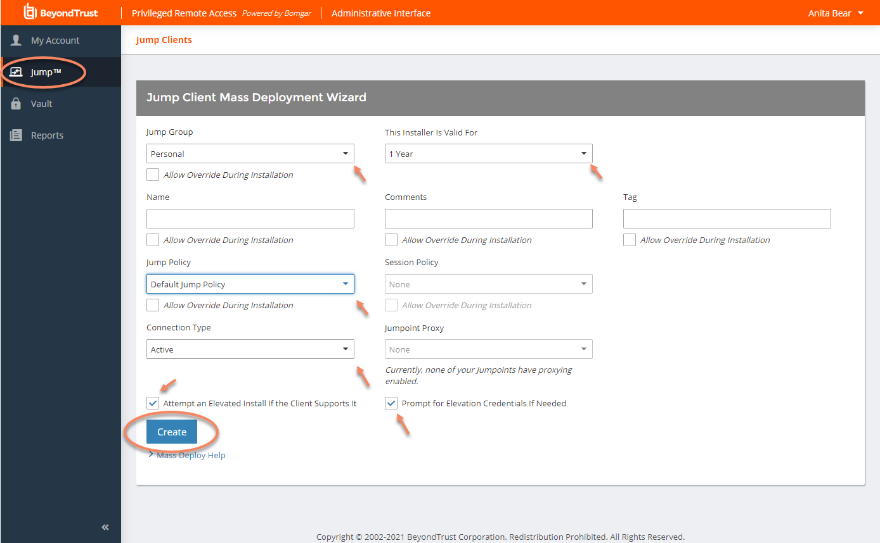
  - Select the Platform you will install the jump client on and click “Download”. **For Macs, we recommend “macOS (for Manual Execution)
  - 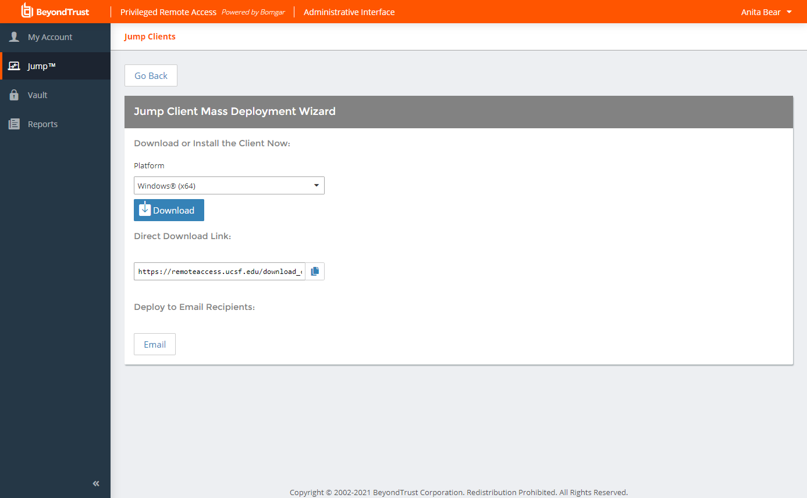
  - Copy the client to the Jump System and install.
  - For Windows:
    - When installing, it will show
    - 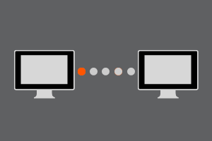
    - Once it goes away, the client is installed. If you want to verify, you can go to Programs and Features in Control Panel
    - 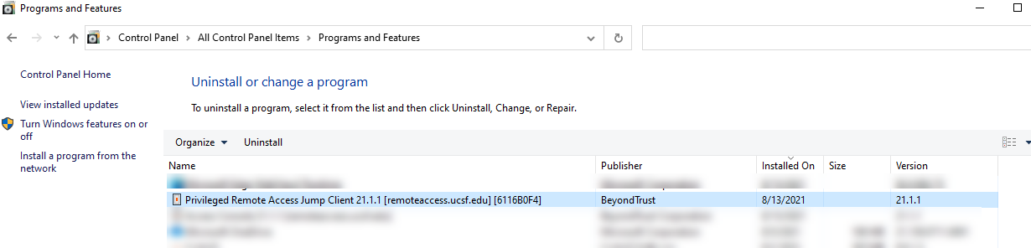
  - For Macs:
    - When installing, it will ask if it is ok to install, go ahead and proceed.
    - You will be prompted to open “System Preferences”, click “Open System Preferences”
      - 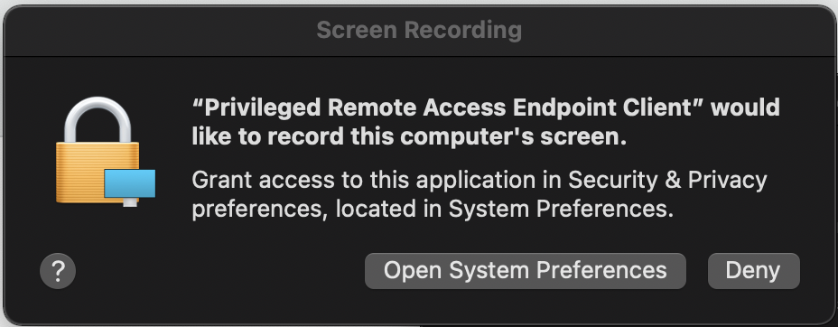
    - Check and allow PRA.
      - 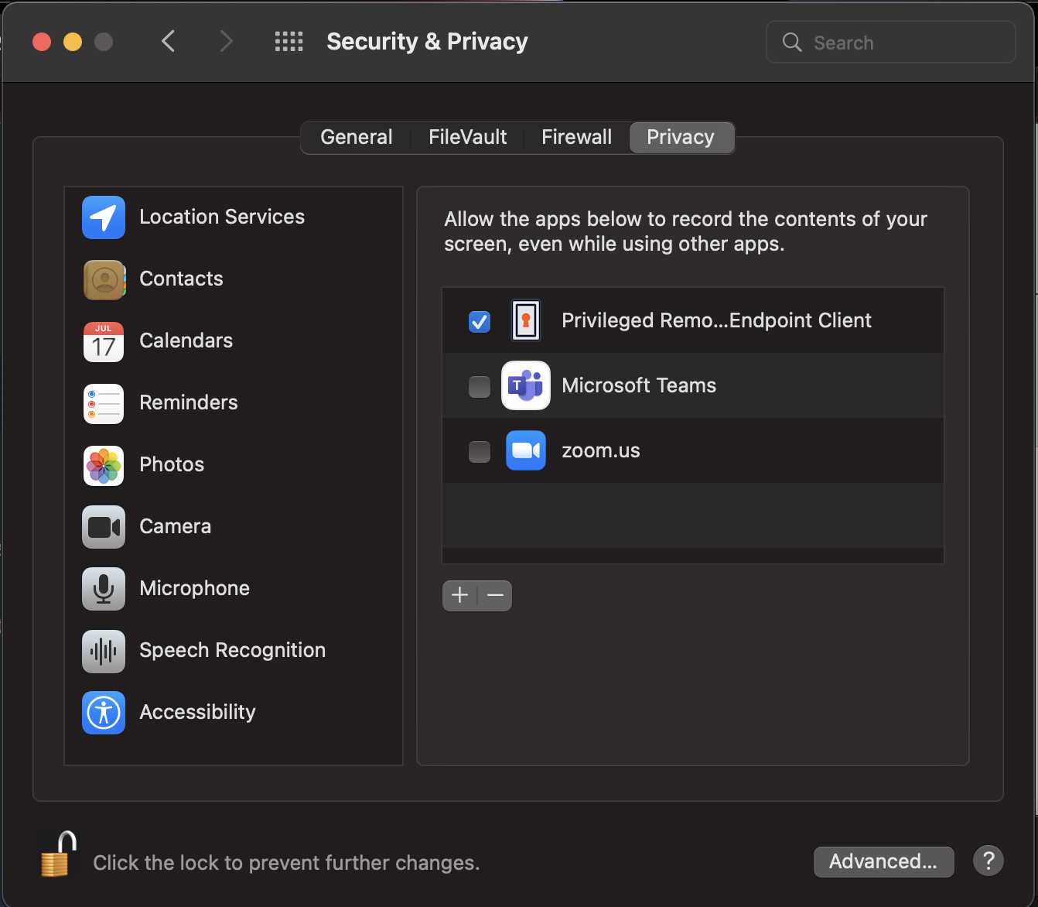
      - It will prompt to restart the app, click “Quit & Reopen”
      - 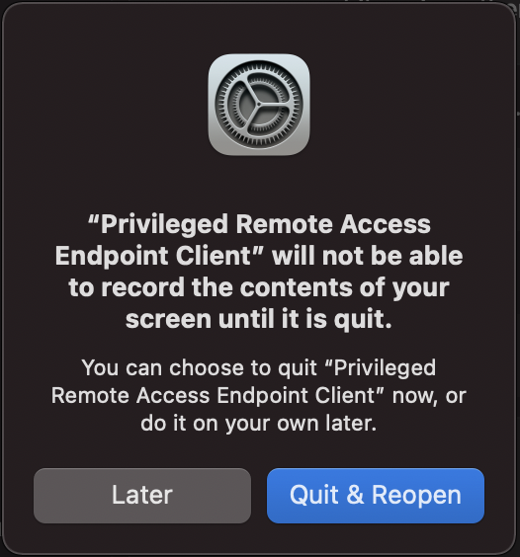
      - The jump client install is **NOT** complete. You will need to install the Access Console with the instructions below.
      - Once you have the Access Console installed, connect to the system and it will ask to configure additional security controls.
        - Make sure you click “Grant Access” to Accessibility and Full Disk Access”
      - 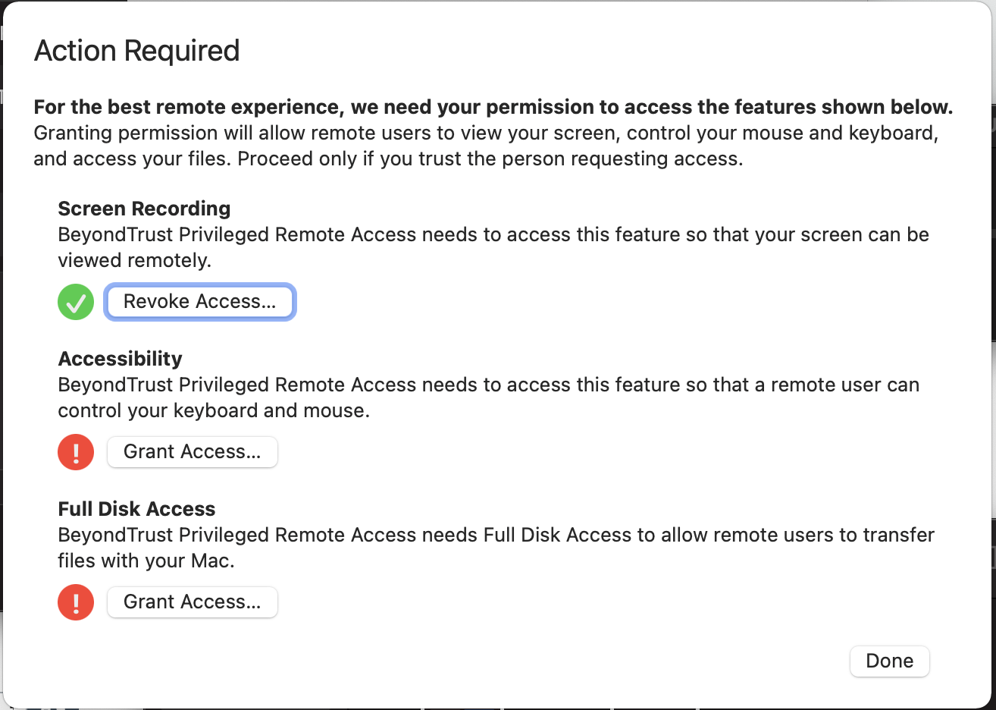
      - After this the Jump Client install is now complete.
Installing Access Console:
- Windows, Mac, and Linux
  - Login to remoteaccess.ucsf.edu/login
  - Under “My Account” and “Access Console”. Select your platform and click “Download Access Console” and run the installer
  - 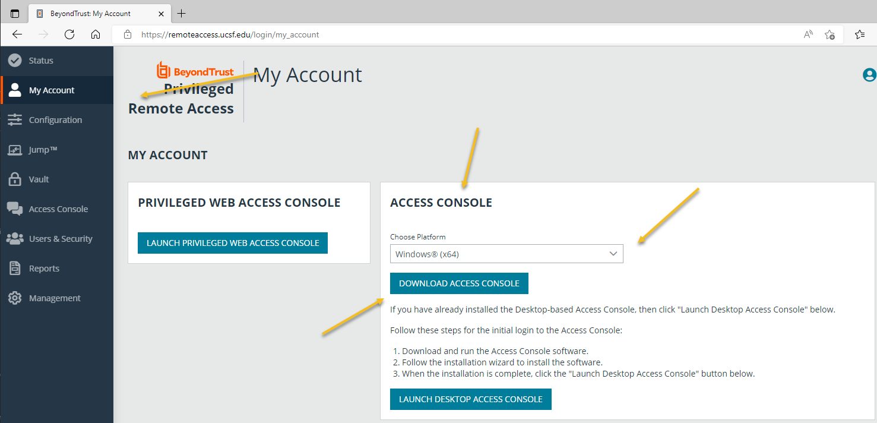
- Android and iOS
  - Apple App Store and Google Play Store
    - Search for “BeyondTrust Access Console”
- Web Console
  - https://remoteaccess.ucsf.edu/console
Access Console:
- Run the BeyondTrust Privileged Remote Access Console
- Make sure to select “SAML Credentials” and click “Login”
- 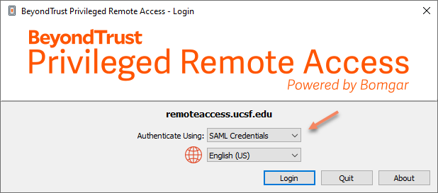
- A web browser will open and prompt you for your MyAccess Login
- Once you login, it will download a token, go ahead and open the token.
- The application will open, and you should see the console
- 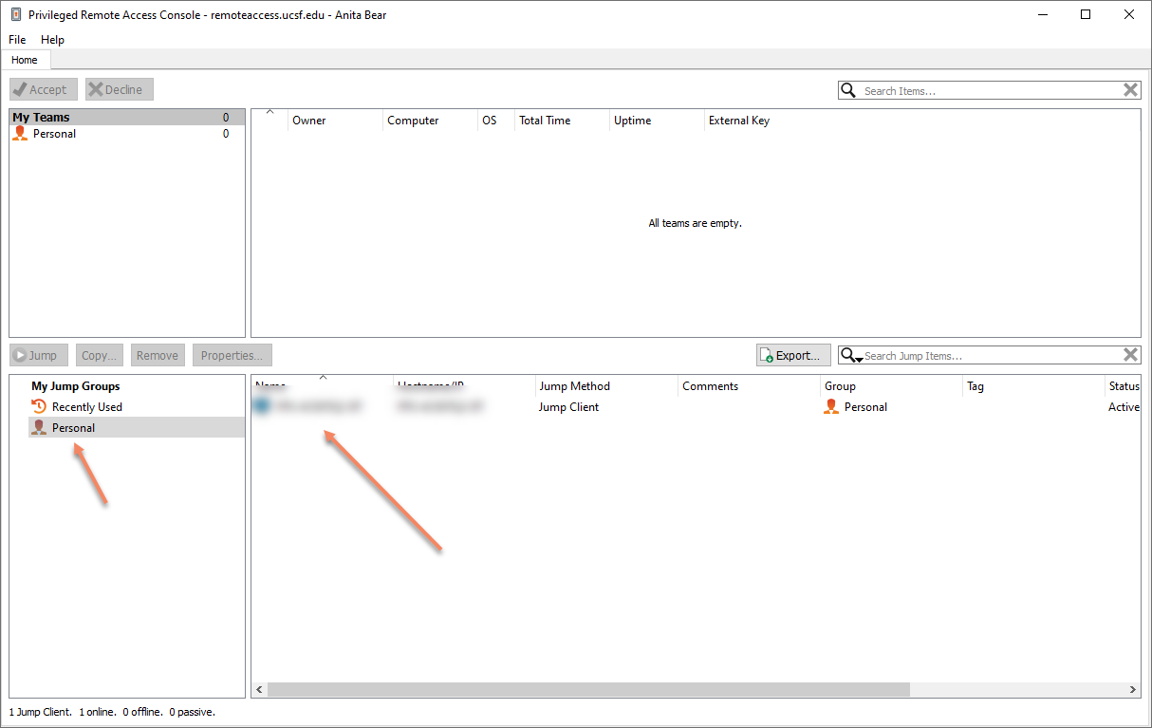
- If you install the jump client, under “My Jump Group”, click “Personal” and you should see the system.
- To remote to the system, double click the system.
- You will see the system screen and be able to login to it.
Access Console Guides:
- Access Console – Windows, Mac and Linux
  - https://www.beyondtrust.com/docs/privileged-remote-access/getting-started/access-console/index.htm

- Access Console – Web Console
  - https://www.beyondtrust.com/docs/privileged-remote-access/getting-started/access-console/web-access/index.htm

- Access Console – iOS
  - https://www.beyondtrust.com/docs/privileged-remote-access/getting-started/access-console/apple-ios/index.htm

- Access Console – Android
  - https://www.beyondtrust.com/docs/privileged-remote-access/getting-started/access-console/android/index.htm
Links:
- https://www.beyondtrust.com/docs/privileged-remote-access/index.htm
Notes:
- If a Jump Client goes offline and does not reconnect to the server for 180 days, it is automatically uninstalled from the target computer and is removed from the Jump interface.

