Cisco Jabber for iPad

Quick Start Document

1. Download the Jabber client from the App store  
     
   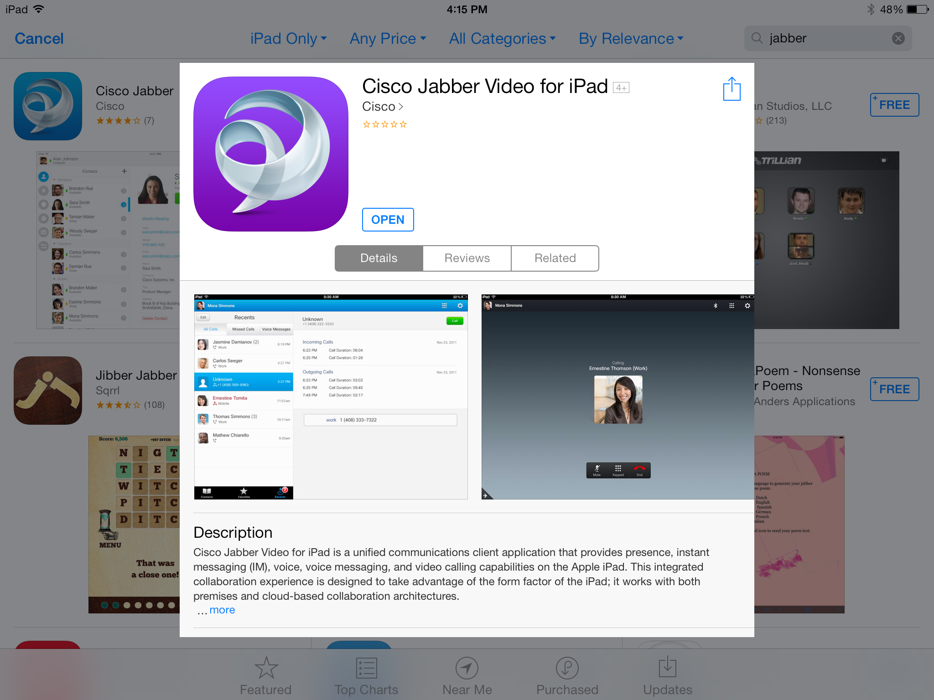
2. Launch the App and enter your UCSF email address.   
   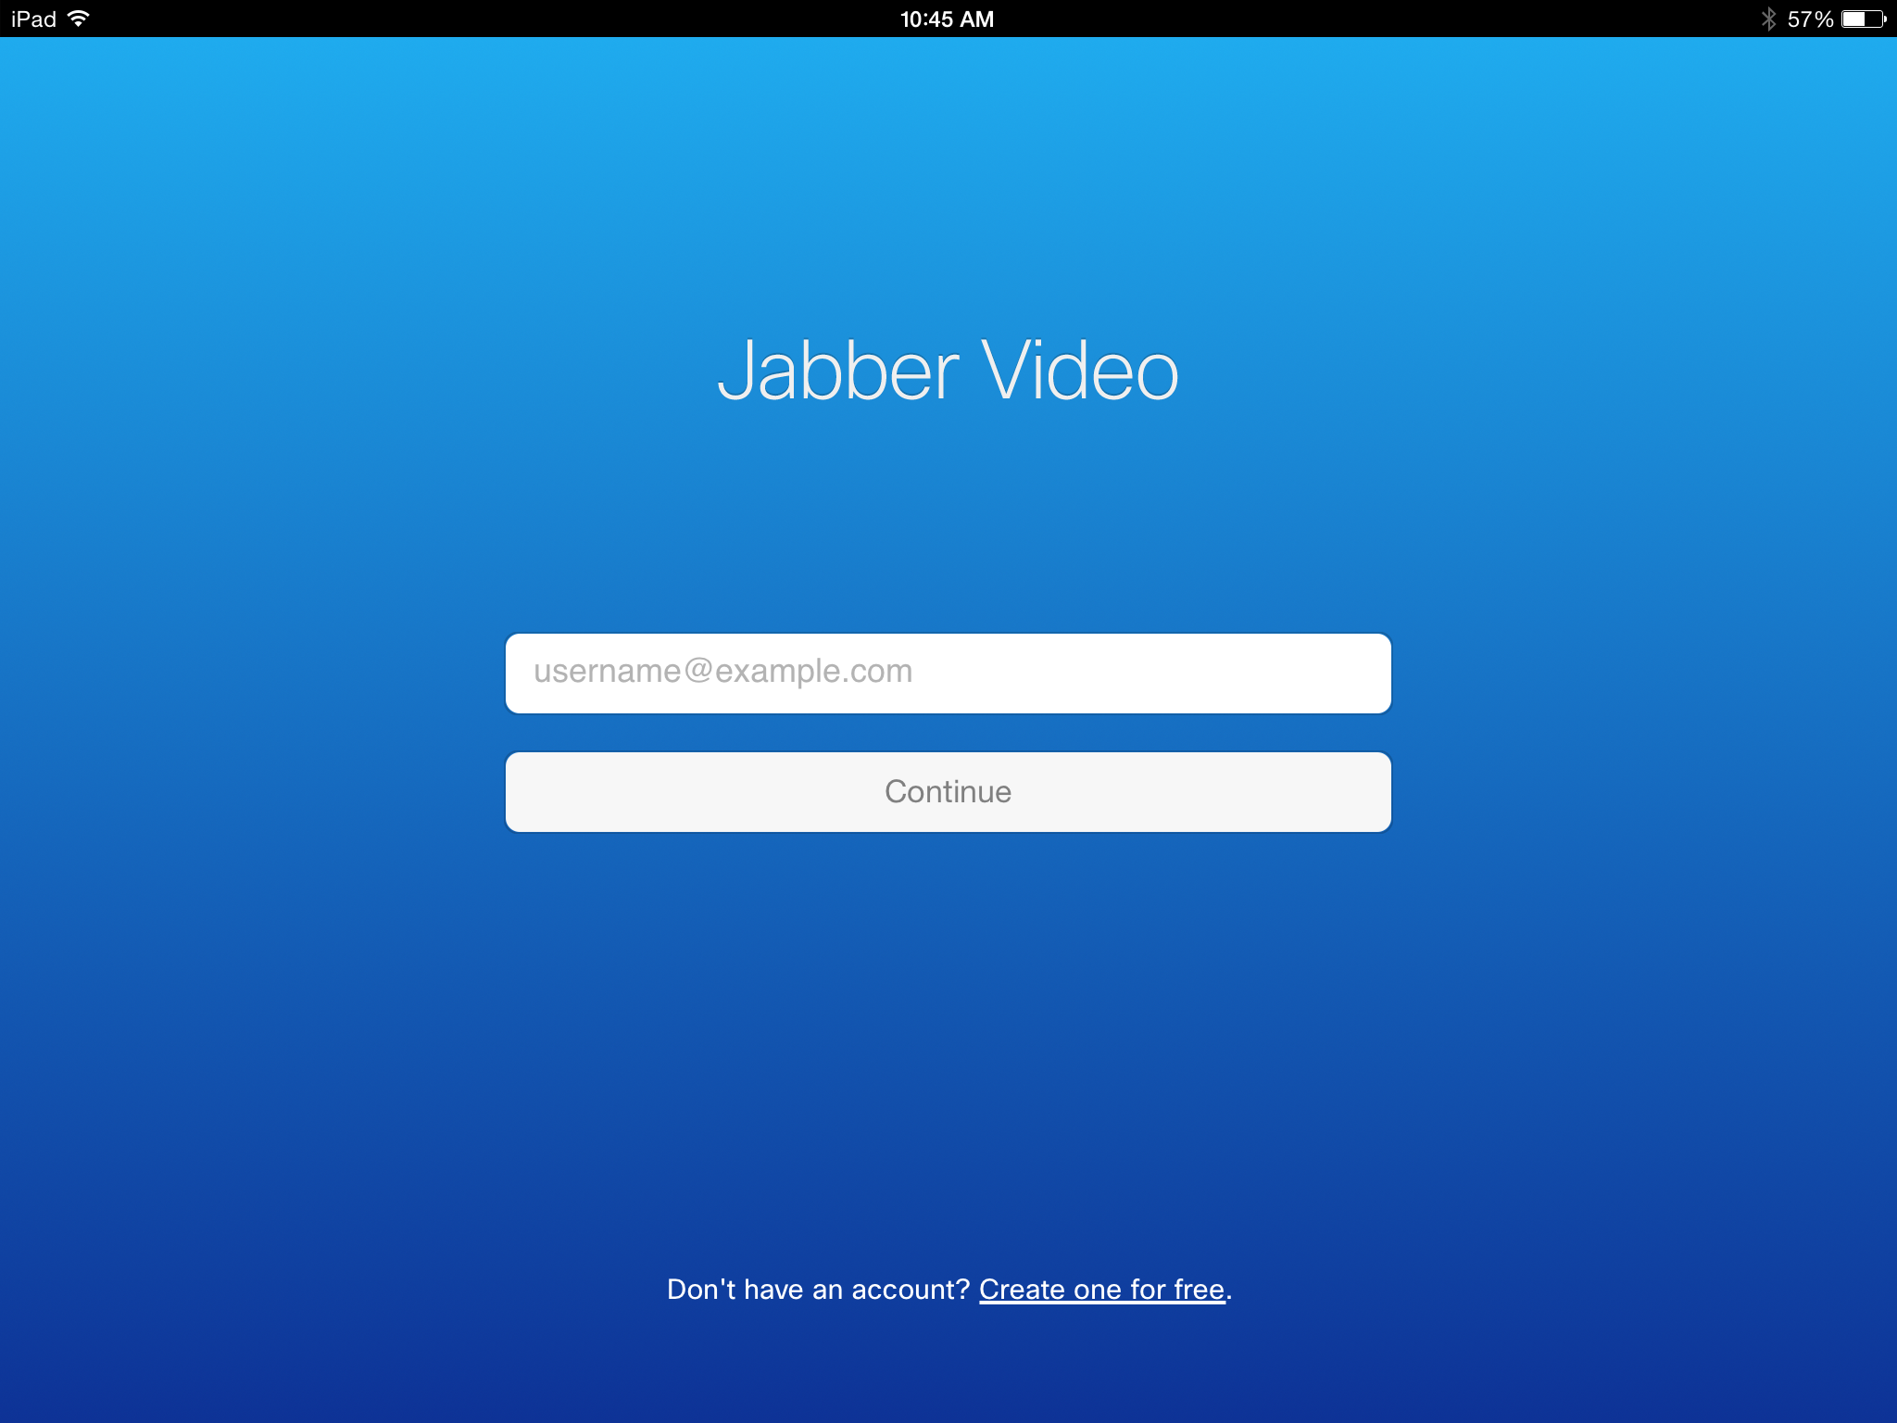
3. Configure the **Telepresence Video Communication Server** option: 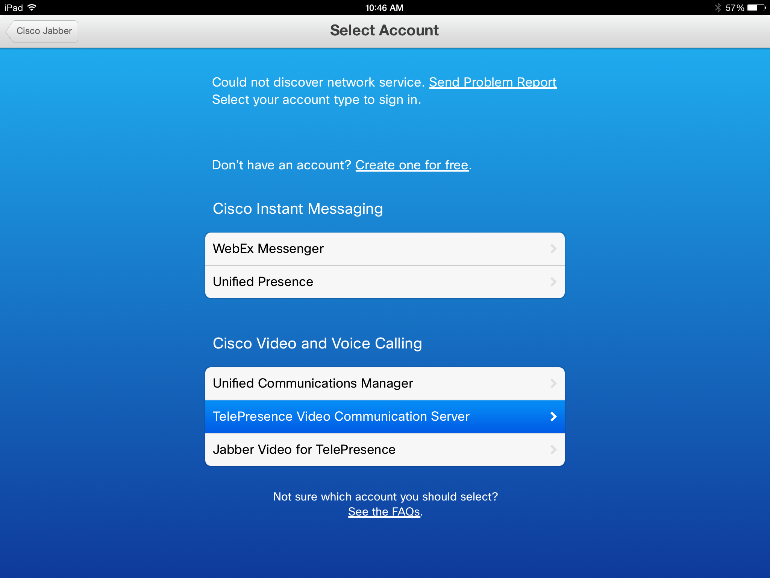
4. Enter your movi account and password and add the other settings shown below. The **Sign In**:  
   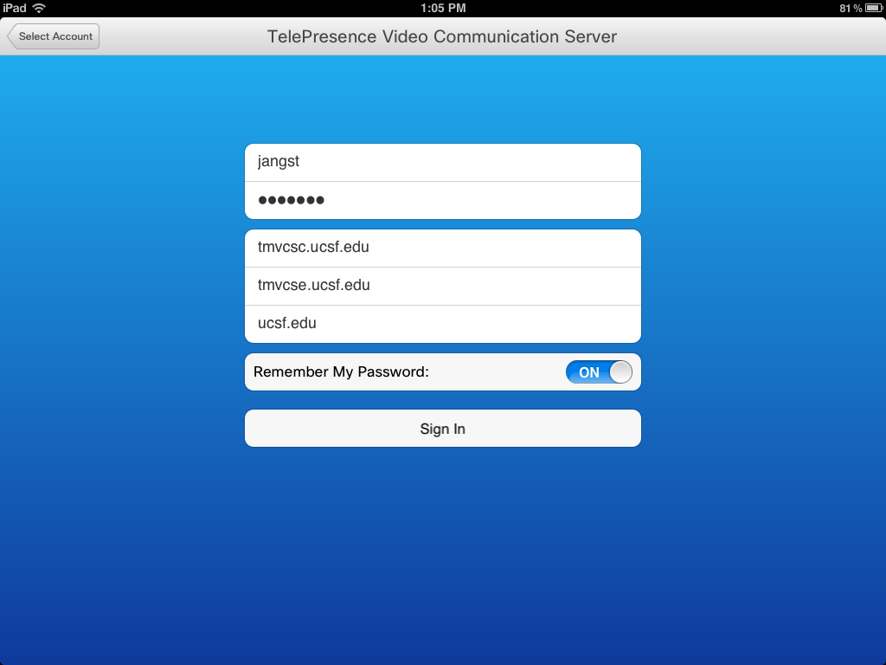
5. Make sure your sound setting is turned on.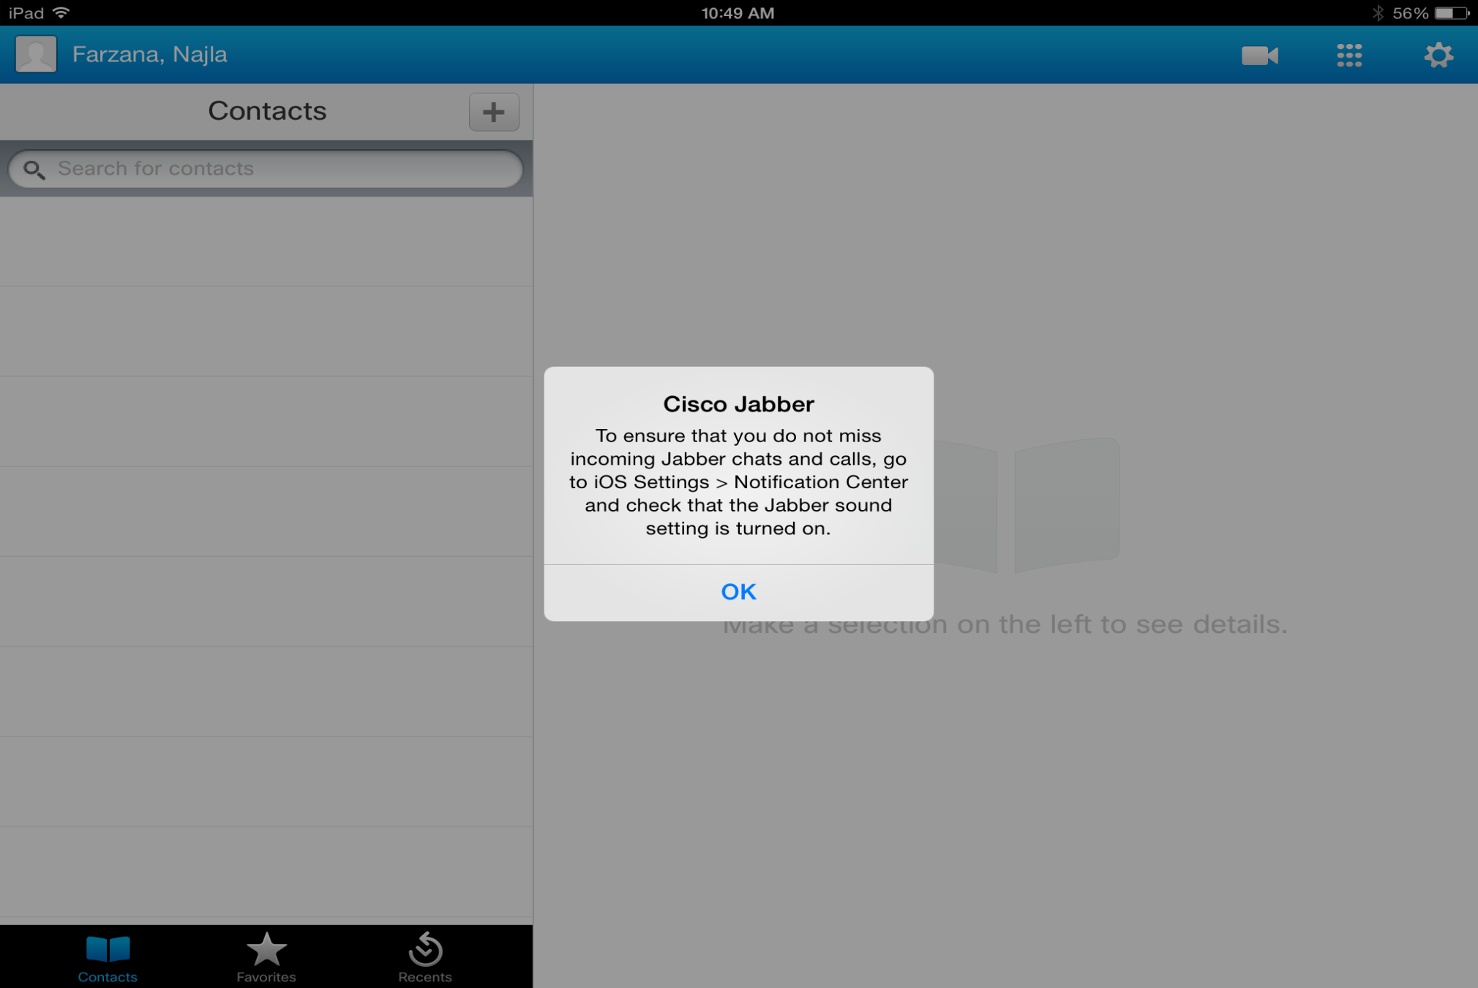
6. You should see a screen similar to this:  
   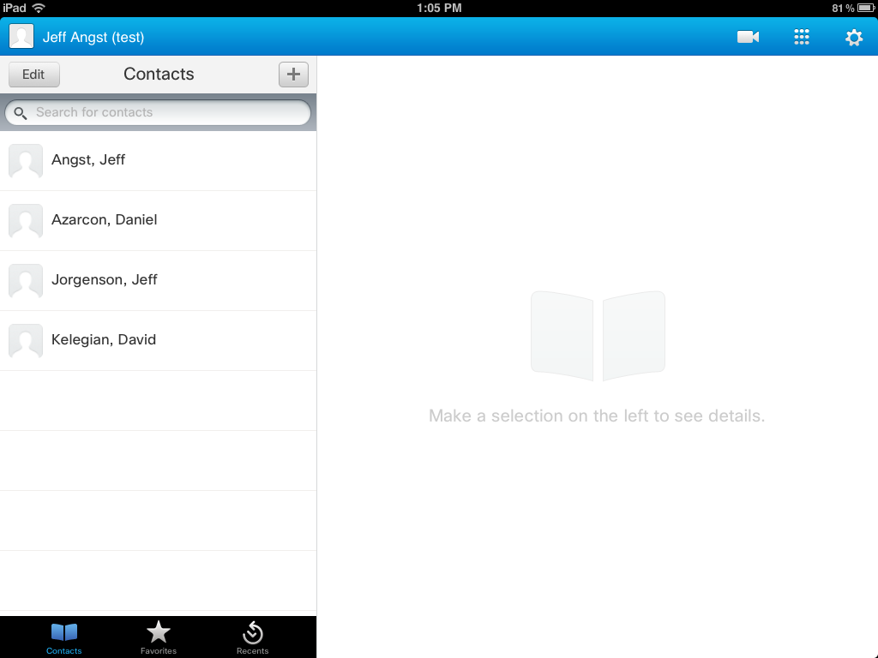
7. Search for contacts in the MOVI directory by selecting **Telepresence Directory** and entering your search criteria. You can save found contacts to your **My Contacts** tab and press the **Call** button to place a call.  
   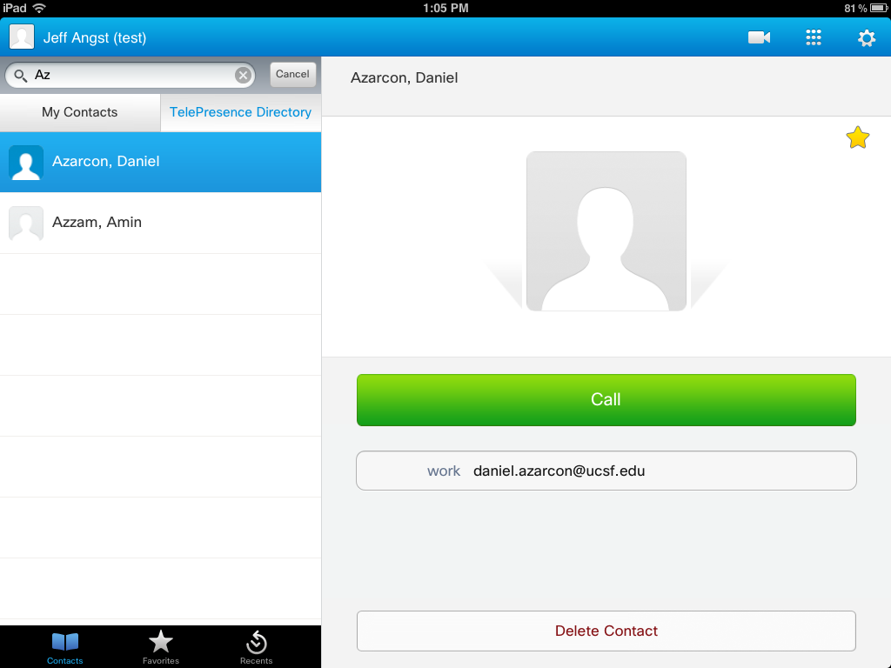

For more information on using the Cisco Jabber foriPad see …