UCSF First Time WebEx User Login
Step 1. Activate your WebEx account – Password Change
First time users will receive an email from “UCSF WebEx Conferencing [no-reply@ucsf.edu].” The email is the first step in activating your WebEx account. The email requests you to create a password for your new WebEx account. Once you receive the email, click on the green “Create Password” button. (See screenshot below)

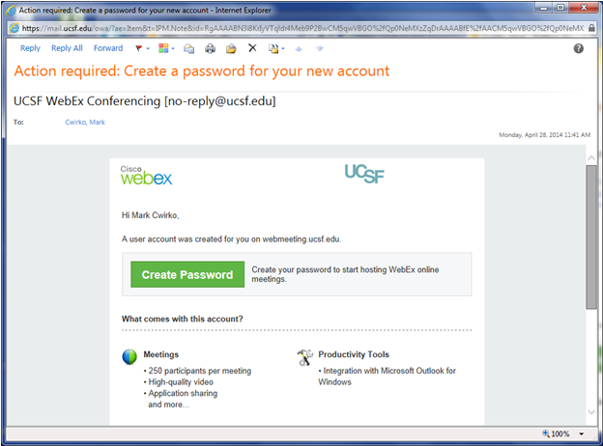

Step 2. Set Password

A new browser window will open prompting you to enter your new password. Current WebEx system password defaults require your password to be the following:
- At least 6 characters long
- At least one alphabetic character (a,b,c…)
- At least one number (1,2,3…)
- At least one special character ($, @, #...)
- At least two-mixed case (A,a,B,b….)

(Note: Password requirements can be modified per UCSF IT password standards)

Enter your new password in the “New Password” field.
Confirm your new password by entering it in the “Confirm New Password” field. (See screenshot below)

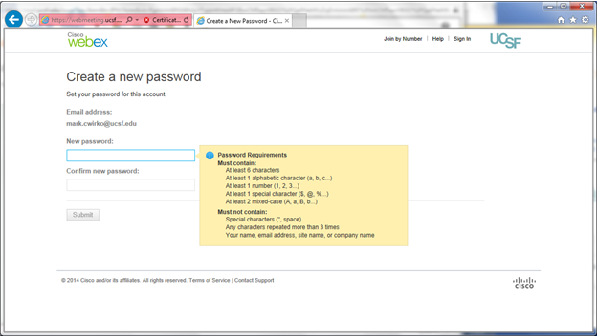

Step 3. Sign In To WebEx

After clicking the “submit” button from the previous step, a new browser window will open prompting you to login with your WebEx credentials. Enter the user email address, and the new password created from previous step, and click “Sign-In.” (See screenshot below)

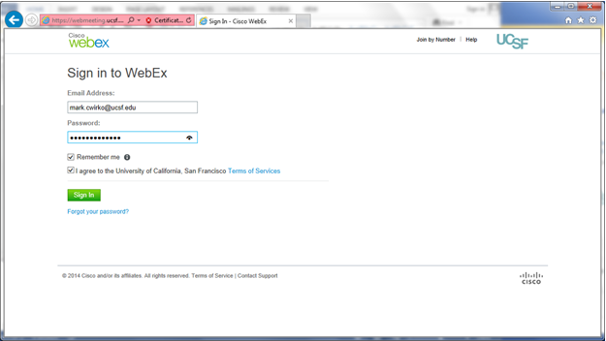

Your new WebEx account has been created, and you should see the following screen. Click “Done”

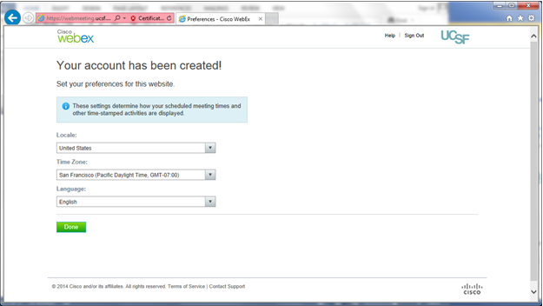

Step 4. WebEx Productivity Tools

After clicking “Done” from the previous step, and new browser window will open prompting to you download the WebEx Productivity Tools. You may or may not want to download the Outlook Plugin at this point. If you do, click “Download Now,” if not, either click “Download Later” or “No Thanks, Start Using WebEx.”

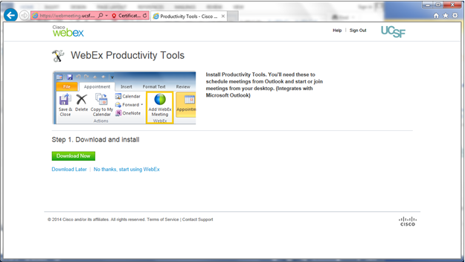

You are now ready to start using the WebEx application, to schedule and attending meetings. Another browser window should open. This is the main WebEx portal to start an immediate meeting, schedule a new meeting or attend a meeting. If you do not see the main site page in your browser window, type in the WebEx URL to get there. The URL for the UCSF WebEx site it: https://webmeeting.ucsf.edu (See screenshot below)

